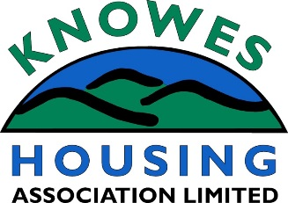

APPLICATION FOR MEMBERSHIP

Membership of Knowes Housing Association is open to anyone over the age of 16 and who has an interest in the organisation. Life membership costs only £1.00 and payment can be made by card direct to our finance section (preferred option) or by cash.

All applications for membership are presented to the Association’s Management Committee for approval. After approval, each new member is issued with a share certificate and a copy of the Association’s Rules.

Please sign below to acknowledge that your application will be presented to the Management Committee

Signature: ……………………………………………… Date: …………………………….

All Association members (over the age of 18) are eligible to stand for election to the Association’s Management Committee. If you are interested in joining the Management Committee, please contact a member of the Association’s staff for further information.

I WISH TO APPLY FOR MEMBERSHIP OF KNOWES HOUSING ASSOCIATION AND ENCLOSE £1.

Title: ……………………. First Name: ………………… Surname: ……………………………..

Address: ……………………………………………………………………………………………….

Postcode: ………………………………

Telephone Number: …………………………………… Signed:…………………………………..

Email address:

Please return to: Knowes Housing Association
10 Field Road
Faifley
Clydebank
G81 5BX

Your application will be placed before the next meeting of the Management Committee.

OFFICIAL USE ONLY:

Date Received: |  |  | Received by: |  | Paid | YES / NO
Date passed to FinanceTeam

